Finding Past Hosting Leads:
There are several reasons why you might want to pull a list of past hosting leads. Going through the entire list of past hosting leads to review why they were closed can be helpful, and so can looking at specific subsets such as leads that were closed because the school was closed as perhaps the school is now viable! Or leads who weren’t reached; we know they were interested at one time and perhaps now is a better time to reach them!
Below are step-by-step instructions for finding each audience.
a) Leads closed because the school was closed
b) Leads who were Not Reached
c) All past hosting leads for a given year
a) Leads closed because the school was closed
Do a Service Case search in Global Link with the following parameters:
Service Type = Host Family
Program Code = Enter the year you want to look up. Repeat the search to look up multiple years.
Area Team = Only required for volunteers who work with multiple teams and for staff.
Add Filter = Close Reason contains school
And Search (adjust Max Results if you get more than 50!)
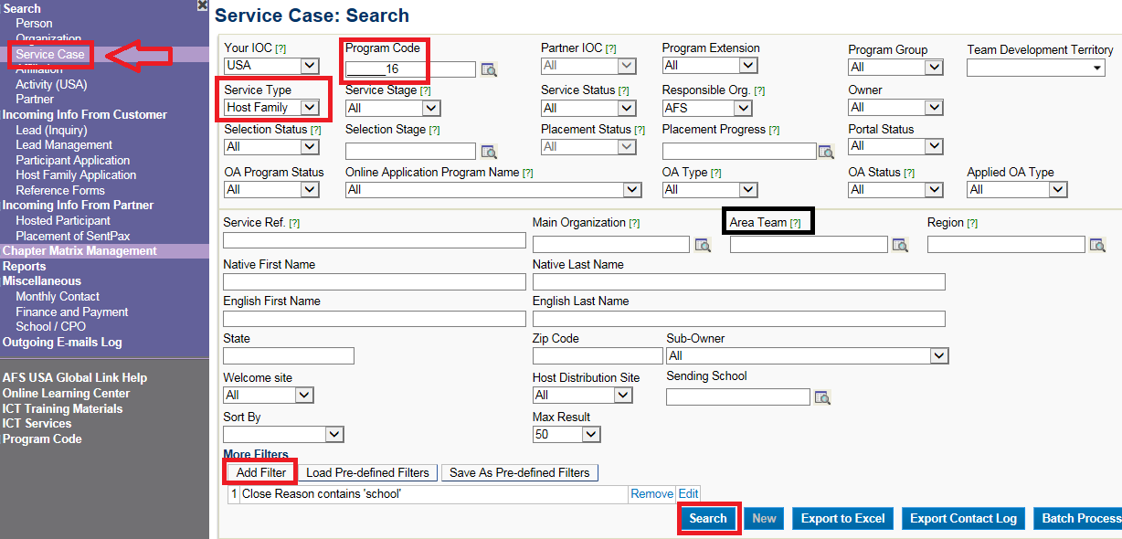
b) Leads who were Not Reached
Do a Service Case search in Global Link with the following parameters:
Service Type = Host Family
Program Code = Enter the year you want to look up. Repeat the search to look up multiple years.
Area Team = Only required for volunteers who work with multiple teams and for staff.
Add Filter = Close Reason contains Not Reached
And Search (adjust Max Results if you get more than 50!)
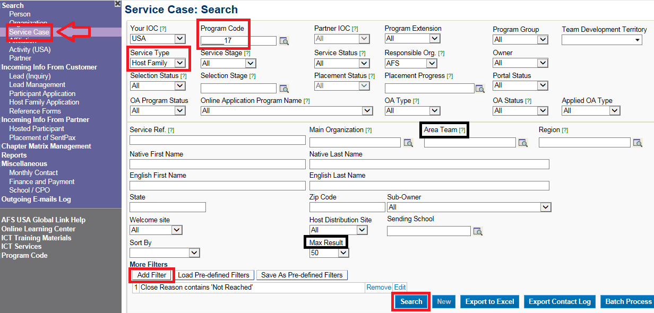

c) Find all past hosting leads for a given year
Do a Service Case search in Global Link with the following parameters:
Service Type = Host Family
Service Status = Closed
Program Code = Enter the year you want to look up. Repeat the search to look up multiple years.
Area Team = Only required for volunteers who work with multiple teams and for staff.
Add Filter = Service Stage is not equal to Participation (this way you will look up all people who did NOT host a student in a given year).
Max Results = Show All
And Search
