Entering Requests in Global Link

- Retrieve the student from the ‘Hosted Participant’ search screen
- Click on the ‘Service Ref’ link of the student
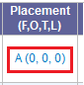

- Scroll down to application distribution section and select ‘new request’

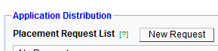

- Select the desired ‘request type’ from the drop down list and click ‘save’

- For Area Team Holds, a Host Family name is required as only two students can be on hold for the same family at one time.

Placed Without Papers Requests

- Update ‘request type’ to ‘Placed without Papers’ and choose the duration (Year, Semester or Welcome)

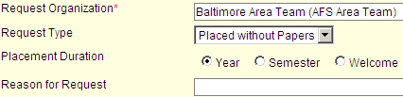

- Assign the host family

  - In the ‘family placement’ tab, enter the requested information by selecting from a list of existing family records in the team by clicking on the magnifying glass next to ‘Family Name’

- If the family is not yet in Global Link, you can select the first option indication a service case does not yet exist:

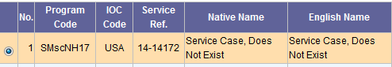

- The fields will automatically fill with the corresponding information from the person’s existing record (or from the place holder record as shown above)

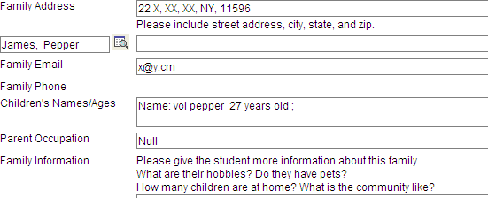

- Click on the ‘school placement tab’ before selecting ‘save’

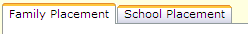

- Assign the host school
  - Select from a list of existing school records by clicking on the magnifying glass next to ‘school name’

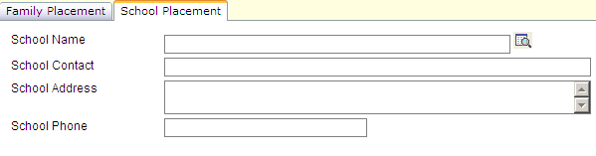

- The other fields will automatically fill in the corresponding information

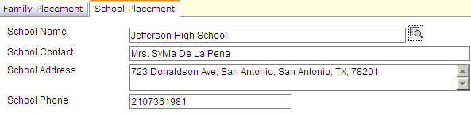

- Click ‘save’ at the bottom of the screen



- You will now see the new request in the application distribution section of the student’s placement information tab

