How to Retrieve Newly Released Hosted Students in Global Link
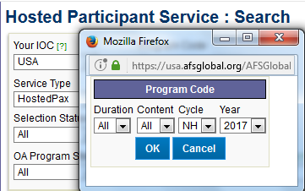
- From the Hosted Participant Search View, select Program Code such as NH 2017

- Under More Filters, click on ‘Add Filter’
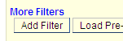
- Select ‘Distributed Date’ ‘is greater than or equal to’ for Search Type, and yesterday’s date (or the date of the last time you searched for students). Or you could search just for students released on March 6th like this:
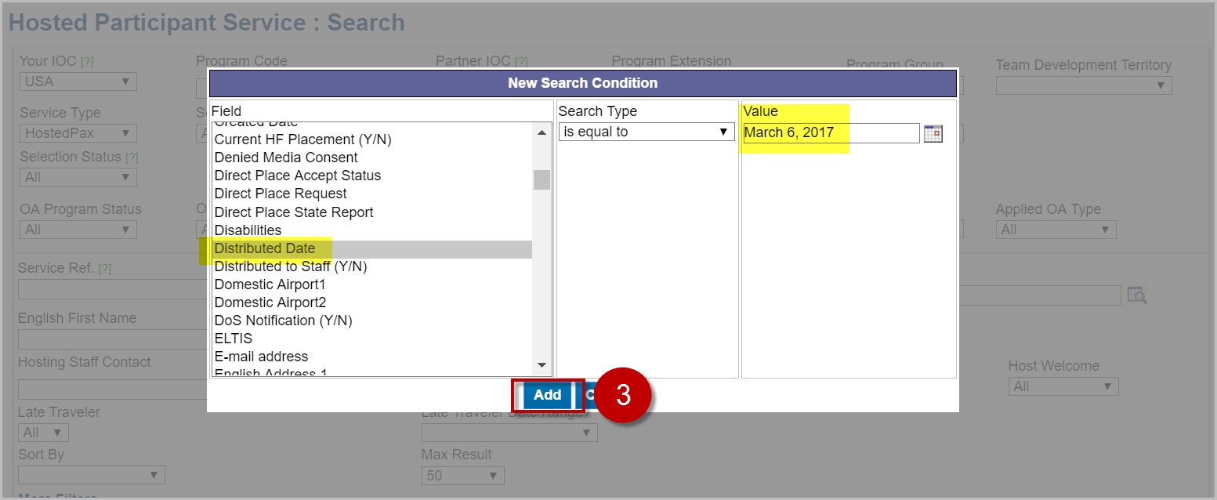
- Click on ‘Add’
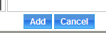
- Click on ‘Search’
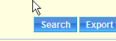
- The list of newly released students (regardless of placement progress status) from the date you specified will be retrieved.
- To narrow your search further, you can select ‘regionally available’ or ‘area team hold’ as the placement progress status, and click on ‘search’ again.
