Guide to Searching for Sponsored Programs Hosted Participant Records

Hosted Participant: Log into Global Link and click on “Hosted Participant”, which is located on the search menu on the left under ‘Incoming Info from Partner’.
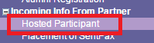
This takes you to the search screen. There are several search fields, but the red boxes below highlight the most important fields needed to search for your hosted students:

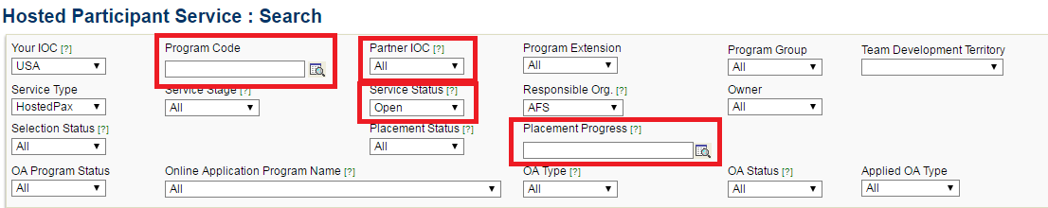

Program Code: Here you can search for students according to program year and cycle by clicking on the magnifying glass next to the search field.
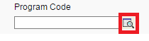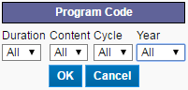

To find Sponsored Program students, choose the following codes:

Duration: Choose YP for year program, SM for semester program or leave blank for both.
Content: Choose ys for YES and cb for CBYX.
Cycle: Choose NH for Northern Hemisphere (this will bring up YES all students except spring-semester Malaysian students) and SH for Southern Hemisphere (only spring-semester Malaysian students; if you search SH students, make the duration code “SM” or leave it blank).
Year: Choose the year the student will arrive.

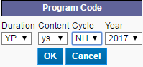
To find all 2017 YES students, set the program code to YPysNH2017.
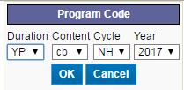
To find all 2017 CBYX students, set the program code to YPcbNH2017.

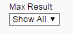
When you search, set the Max Result to “Show All”.

Partner IOC: Use this field when searching for a group of students from a particular country.
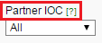

Service Status: Make sure this is set to ‘open’ in order to retrieve students who are currently applying or on program (student who withdraw, are rejected, or have completed a program will have closed service statuses).
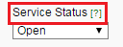

Placement Progress: This status indicates which stage the student is regarding availability and placement. Click on the magnifying glass next to the search field to retrieve a group of students in a specific status.
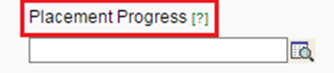
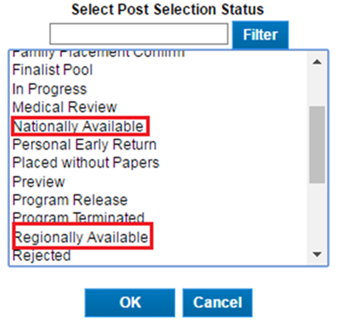
Choose the appropriate status from the list and click on ‘OK’.
•When a YES student does not have an active hold by an area team, his/her status will be “Nationally Available”.
•When a CBYX student does not have an active hold by an area team, his/her status will be “Regionally Available”.
Filters: To search by even more specific criteria, you can use the filter feature at the bottom of the search screen. Click on ‘Add Filter’:
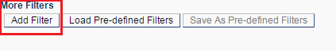
To search for students of a specific gender, select ‘Gender (M/F)’in the Field menu; search Type ‘is equal to’; enter either ‘M’ for male or ‘F’ for female in the Value field:
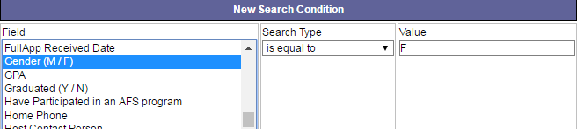

To search for students with certain hobbies and interests (as listed in the ‘About Me’
section of the student bio), select ‘About Me’ from the Field menu; Search Type
‘contains’; and in the Value field enter the key word(s) (ie: soccer). A full list of About
Me Search Terms can be found here.
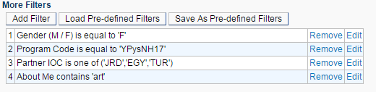
This search is for a female student who is part of the 2017 YES scholarship from either Jordan, Egypt, or Turkey, who likes art.

Once you’ve entered the desired criteria, click on ‘Search’ from the bottom right hand corner of the screen.
