Submitting Form D in Global Link
1. Log into Global Link using your ID and Password
2. Click on the Host Family Application button in the left side menu
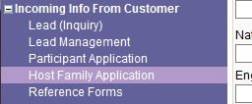
3. Use the search fields to look up the host family with whom you are working and click Search
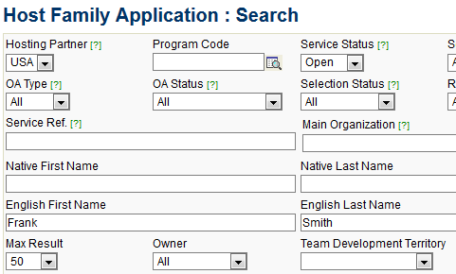
4. When the family shows up under the results click on the blue "Service Ref." link to open the Service Case Detail page
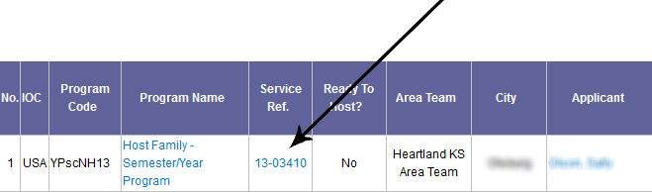

5. From the buttons at the top of the screen, choose Upload/Fill In App Form
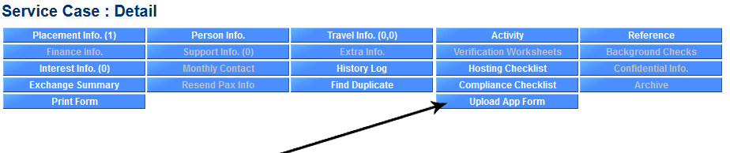
Please Note that you must have one of the following Global Link Affiliations or the Upload/Fill In App Form button will be grayed indicating that you are not allowed to perform this function.
- NSLI-Y Phone Interviewer  - NSLI-Y Interviews Coordinator  - NSLI-Y Interviewer  - Sending Volunteer | - Sending Interviewer  - Sending Interview Coordinator  - Sending Coordinator  - Hosting Volunteer | - Hosting Coordinator  - Hosting Interviewer  - Compliance Coordinator  - Chair
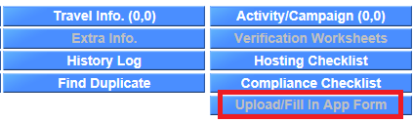

6. After clicking "Upload/Fill In App Form" you will be asked which form you'd like to upload. In this case you would, of course, select "Create" to the right of Form D: Host Family Interview.
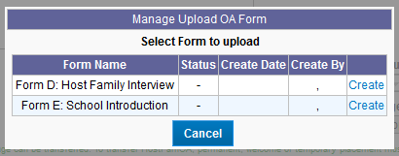
7. At the top, select whether you would like to upload a document or fill in the form directly into Global Link.
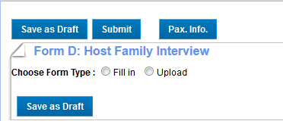
  - If you choose to “Upload,” you will need to enter the date of the interview and if it is a single or two-parent family:
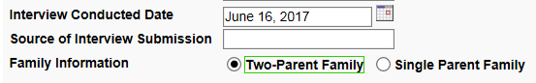
  - Then you will need to Upload your Interview Form. The “Browse…” button will allow you to browse your computer to find your electronic version of the Form D. Click “Upload File” after you find it.
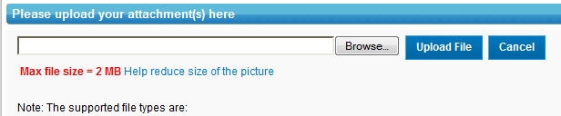

  - Next you will need to enter in your name to serve as an electronic signature:
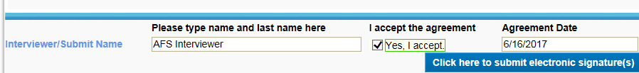

  - And finally you can submit the interview!
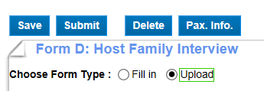
9. To verify that your Host Family Interview was submitted successfully, you can click again on the Upload/Fill In App Form button to see if the status now reads “Submitted”
