Submitting PAF Placement Acceptance Form in Global Link
1. Log into Global Link using your ID and Password
2. Click on the Host Family Application button in the left side menu
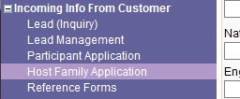
3. Use the search fields to look up the host family you are working with and click "Search"
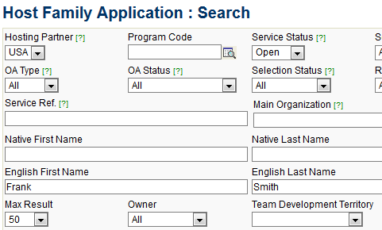
4. When the family shows up under the results click on the "Service Ref." link to go directly to the applicant's service case screen
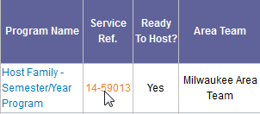

5. At the top of the screen, click on the "Upload/Fill In App Form" blue button
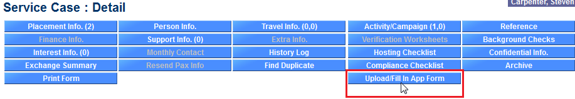
6. In the new window that opens, look for the "PAF: Placement Acceptance Form" option and click "create"
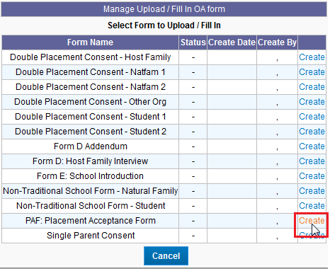
Please Note that you must have one of the following Global Link Affiliations or the Upload/Fill In App Form button will not be available to you.
- NSLI-Y Phone Interviewer  - NSLI-Y Interviews Coordinator  - NSLI-Y Interviewer  - Sending Volunteer | - Sending Interviewer  - Sending Interview Coordinator  - Sending Coordinator  - Hosting Volunteer | - Hosting Coordinator  - Hosting Interviewer  - Compliance Coordinator  - Chair
7. Fill in the "Submitted by" field with your name and select the date the PAF was signed (as appears on the PAF) and click "Save"
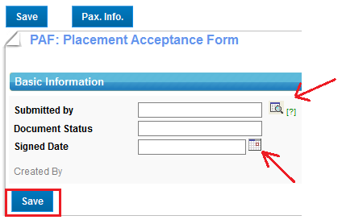
8. After clicking "Save," an option to "Upload New File" will appear. Click "Browse" to search your computer for your saved PAF.
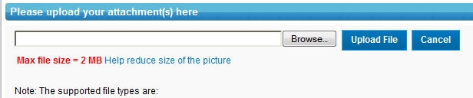
9. Be sure to then click "Upload File" !
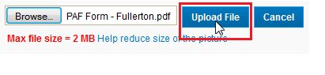
10. The file you loaded should now appear. Click "Submit" to be done!

11. Finally, you can see that your form was submitted by going back to the "Upload/Fill In App Form" button
Contact your Team Development Specialist if you have any questions or concerns.

