Forwarding Bios and Get to Know Emails

Retrieve a list of students from the ‘hosted participant’ search screen in Global Link

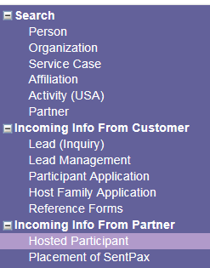

Click on the boxes next to the names of the students whose bios you would like to forward

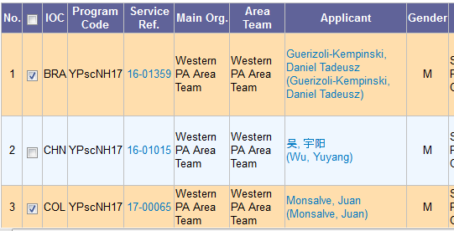

Click on Generate Bios or Generate Get to Know from the top of the search list

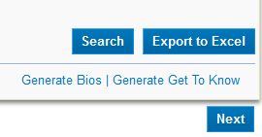

The Bios or Get to Knows will open in a new window. You can save them as PDF documents by clicking on Print or you can click on Email from the top of the page to send directly to a family:



Enter the email address and feel free to edit the subject line and write a brief message in the box provided. When finished, click Send.

