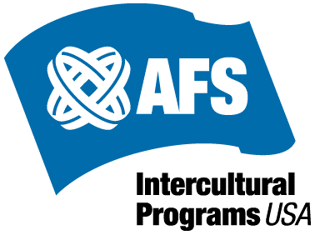 | AFS Re-entry Orientation - Participant Evaluation
1. I currently find myself in this stage of the re-entry phase of cultural adaption:
a) Honeymoon
b) Reverse Culture Shock
c) Recovery
d) Reintegration
2. The country I studied abroad in was: _________________________________

3. Please rate your overall experience studying abroad in this country (1=Poor & 5=Excellent)

1 2 3 4 5

Comments:

4. How effective did you find the re-entry orientation in terms of helping to cope with your re-entry process? (1=Not Very Effective & 5=Very Effective)
1 2 3 4 5

Comments:

5. Did you find the activities in the orientation beneficial to helping increase your awareness and personal growth experience as an AFS Returnee? (1= Not Very Much & 5=Very Much)
1 2 3 4 5

Comments:

6. Please note any additional feedback about the event the other side of this page. (i.e., organization and logistics, timing, flow, facilities, refreshments, other). Thank you!

